**RESUME**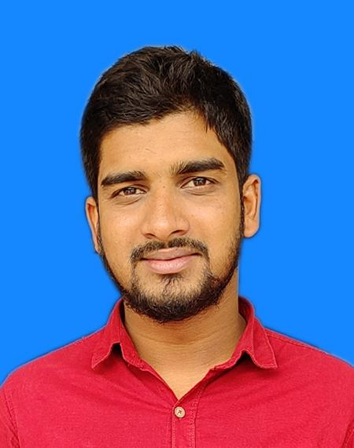

**OF**

**MD. AZIZUL ABIR SIAM**

**Mailing Address:**

**Village-Batali ,Sheikh Bari**

**P.O: Betagoir (2223), P.S.- Nandail, Dist.- Mymenshingh.**

**Contact: 01682-952651**

**E-mail: siamicon16@gmail.com**



Looking for a career where there is an Equal Opportunity of growth & Development with challenging Environment that I can show strong sense of responsibility, dignity of work and devotion for building a bright Career and Developing the Organization.



**Diploma In Engineering (Duration: 4 Year)** 

Institute : Kishoreganj Polytechnic Institute

Location : Kishoreganj

Group : Computer Technology

Result : 3.12 (Out Of 4)

Passing Year : 2017

Board : Dhaka

**Secondary School Certificate Examination (S.S.C)** 

Institute : Mukul Niketon High School

Location : Mymensingh Sadar, Mymensingh.

Group : Science

Result : 4.13(Out Of 5)

Passing Year : 2013

Board : Dhaka



Computer Office Management: MS Word, MS Excel, MS Access, MS PowerPoint, Internet Browsing Etc.



**Bengali**: Extensive communicative skill as native one.

**English**: Good in listening, reading, speaking and writing.



Reading books, Newspapers and Magazines,Travelling new place.



* One year experience of Accountant at the showroom level of H Power Motors Ltd.
* Three years experience of Sales and Marketing at Yokohama Labels & Printing BD.



* Full Name : Azizul Abir Siam
* Father’s Name : Sheikh Shahjahan Kabir
* Mother’s Name : Laily Kabir
* Date Of Birth : 31 Dec. 1998
* Sex : Male
* Marital Status : Unmarried
* Blood Group : O (-Ve)
* Religion : Islam
* Nationality : Bangladeshi By Birth.
* National Id : 915 519 5804
* Present Address : Village- Batali, Sheikh Bari

P.O- Betagoir (2223),

P.S.- Nandail,

District- Mymensingh.

* Permanent Address : Village- Batali, Sheikh Bari

P.O- Betagoir (2223),

P.S.- Nandail,

District- Mymensingh.

**Reference :**

**Md. Homayun Kabir Lavlu**

Manager

KABIR STEEL MILLS LTD (KSRM)

Mymensingh Zone.

Mobile No: 01680-28 70 44

**Acknowledgement:**

I do hereby declare that all information here is true to my knowledge. If required and where applicable, this document can be supported by appropriate authentic certificates / Papers.



--------------------------------- Date:

**Azizul Abir Siam**